Arc Length, Sector Area, Segment Area

Find the shaded area. On problems 1-3, find the arc length for the shaded sector also.
1. A_{sector} = _____________  Arc length = __________  90˚  120˚ | 2. A_{sector} = _____________  Arc length = __________  60˚ |  | 3. A_{sector} = _____________  Arc length = __________
4. A_{segment} = _____________  60˚ | 5. A_{segment} = _____________  120˚ |  | 6. A_{segment} = _____________
7. Find the degree measure of the arc of a sector with area 50π if the area of the circle is 400π. |  | 8. A cake is cut into 8 equal pieces and each piece has an arc length of 6.28 in. Find the diameter.  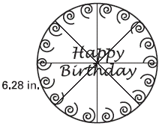
9. Two circles have radii 3 cm. and 5 cm. Find the ratio of their areas. |  | 10. The areas of two circles are in the ratio 16 to 9. Find the ratio of their radii.

